furrow pattern remained. On those lands that are particularly well adapted to permanent grass and have never been subsequently ploughed, the ridge and furrow markings remain visible in the landscape.
Fig 5.8 Enclosure field pattern showing both the rectangular straight-edged fields and fields with the gentle backwards S-shaped boundaries determined by the shape of the open field strips in the Ardington/Lockinge area.
Source: MERL, University of Reading

The enclosure award only laid down the ring fence boundaries of a holding; it was up to the owner or his tenant to decide where to place the internal boundaries. Because parliamentary enclosure involved very different land qualities and uses, there was considerable variation in field patterns. On the arable, the length of the rotation, whether it was four, five, six, or even eight or more years long, would determine the division of the fields. This, in turn, was largely governed by the type of soil available. Fields for pasturing livestock were often quite small. The large fields associated with Tudor and Stuart enclosures were found to be too large and were often divided. Livestock management, particularly disease control, along with good grassland husbandry were simpler in smaller fields. The hedges also provided shelter for the animals. Robert Bakewell from the county of Leicestershire and best known for establishing the Leicester breed of sheep, believed ‘that fifty acres of pasture ground divided into five enclosures will go as far in grazing cattle as sixty acres in one piece.’ For these reasons, fields devoted to pasture and meadows were generally smaller than the arable fields.

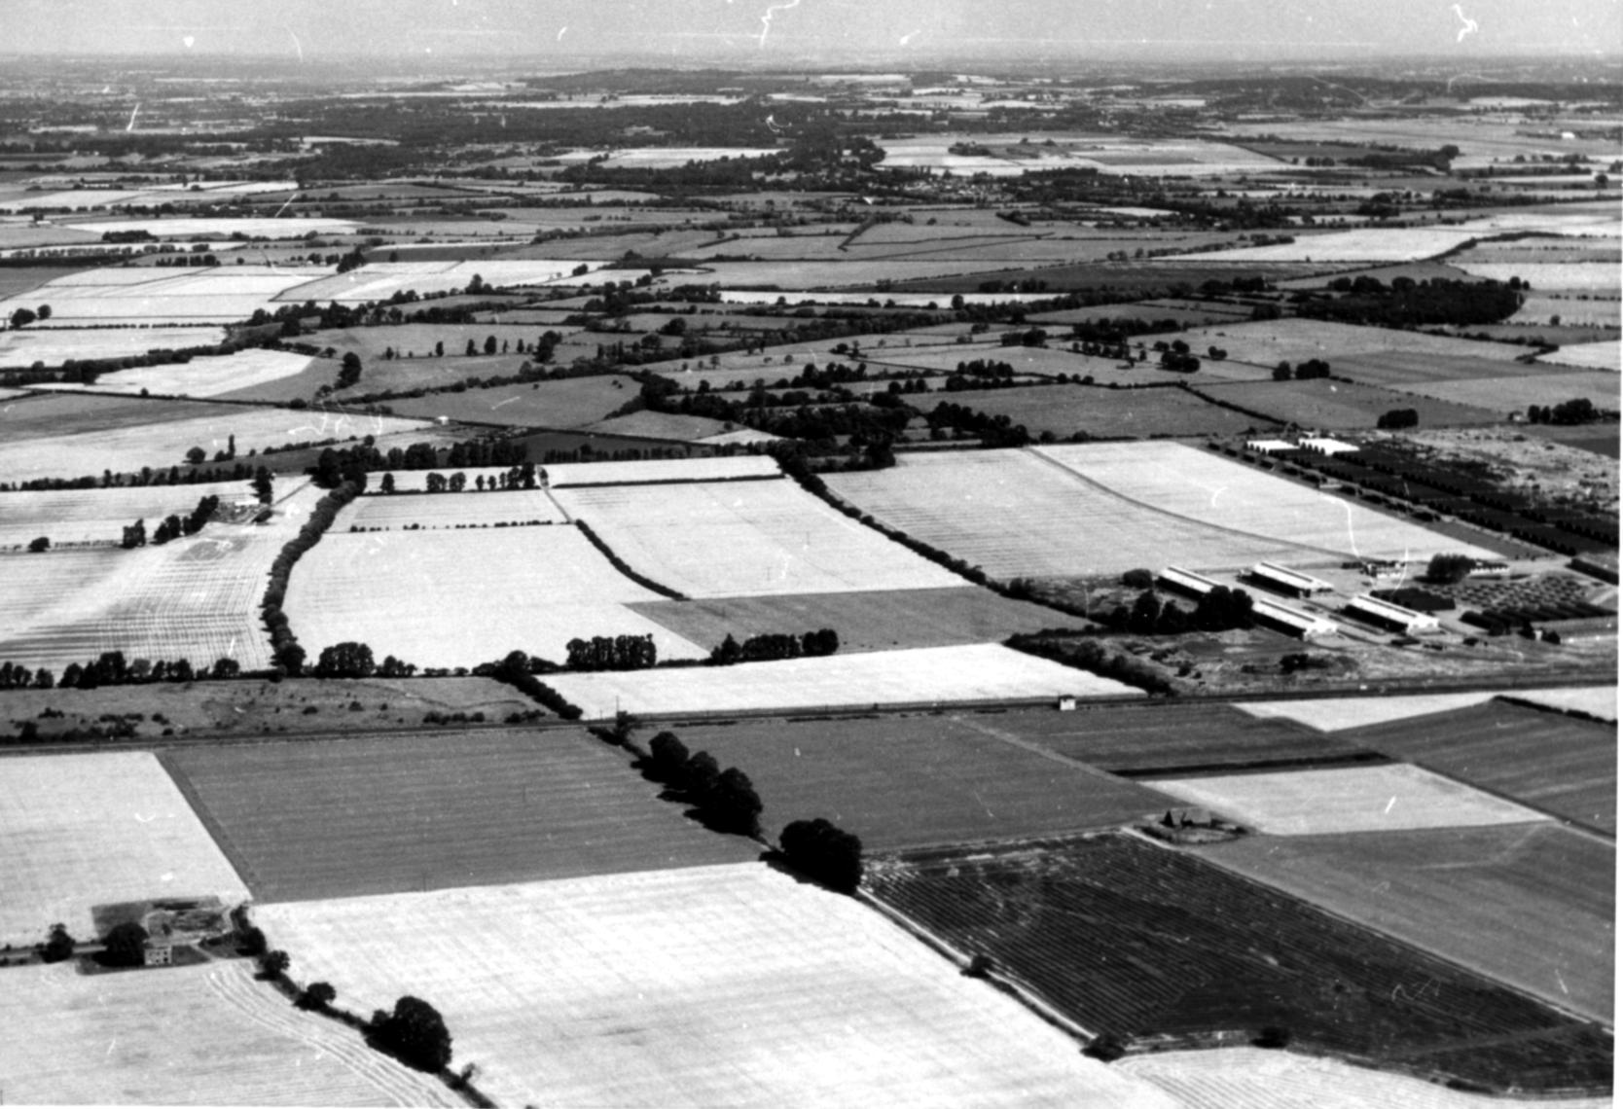
Although parliamentary enclosure tended to complete the process by which all the land, apart from occasional areas of common, in a parish was held in severalty, the parish was rarely enclosure by a single means. The post-enclosure landscape contained areas newly enclosed by award along side much older ‘ancient enclosures’. While some of the small haphazard areas of piecemeal enclosure taken out of the arable or commons disappeared at the time of the parliamentary enclosure, larger areas of non-parliamentary enclosure remained untouched. For this reason a map of a parish after parliamentary enclosure often showed fields with variety of shapes and sizes. However, the shape of many fields enclosed by act of Parliament quickly identifies them. Rectangular fields with incredibly straight boundaries are quintessentially parliamentary enclosure fields. The working map for the enclosure at Ardington demonstrates the complete disregard often paid to the older field system (see fig 5.2). Many of the allotments have been laid out perpendicular to the new enclosure road in fields with slightly less than right-angled corners and straight edges. This was not always the case. In some situations, possibly determined by the road system or by geography, or even just because it was the simplest decision to take, field boundaries could follow the boundary patterns in the old fields. Most often there would be a combination of both. Aerial photographs demonstrate this well. Figure 5.8 taken in the 1960s over Lockinge and Ardington shows a combination of straight-edged and gentle reversed S-shaped boundaries in the fields created by parliamentary enclosure.

Hedges and Woodlands

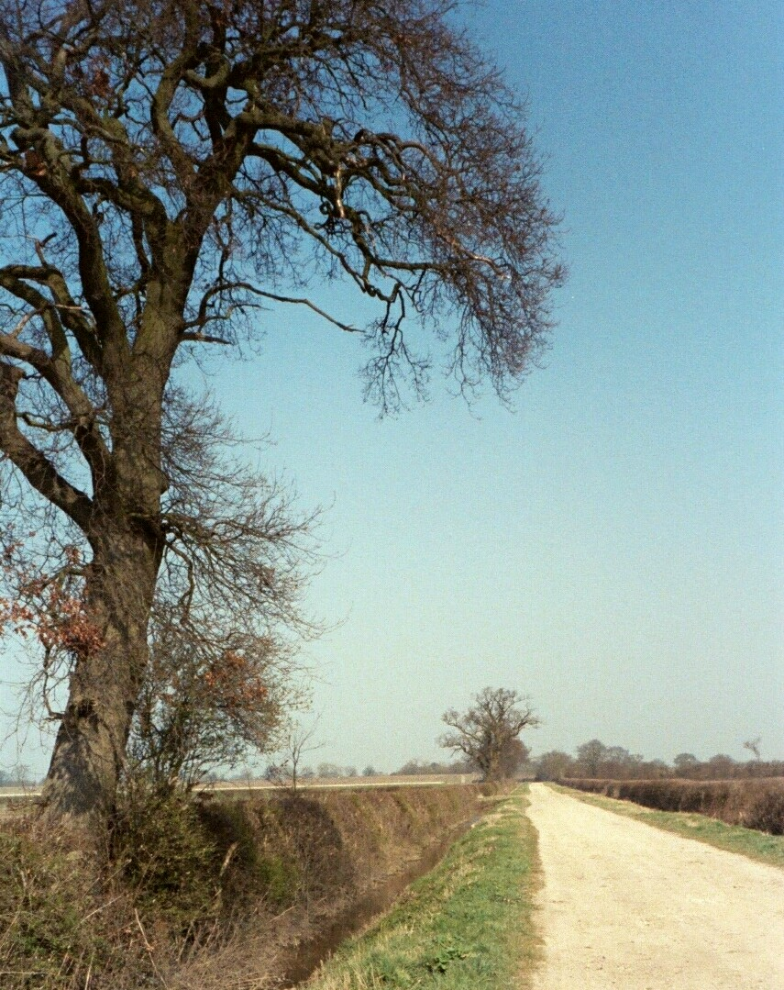
Hedges are probably the most widely recognised feature of an enclosure landscape (see fig 5.9). Within six to twelve months of an award being made, the hedges and ditches along the roads had to be planted. The hedge typically was a double row of hawthorn – also called quick or whitethorn. Instructions for planting the hedges were sometimes very specific. At Great Shefford the hedges were to be made with 100 quicks of 3 yrs growth, per lug, pole, or perch of 16.5 feet. The function of the hedge was solely to delineate the property, to provide a degree of shelter, and to provide a stock-proof barrier. Ideally it was as narrow and compact as possible. It was calculated that on a farm of five hundred acres, forty acres could be taken up by hedges. Between 1750 and 1850 200,000 miles of hedge was planted in England as a result of enclosure. It was also one of the most expensive elements of enclosure. The plants were purchased from nurseries, by this time located around most market towns. In 1766, for example, William Pendar of Woolhampton in Berkshire included an estimate for 4000 quicksets at five shillings in an estimate for Lord Bruce of Tottenham at Savernake in Wiltshire. In addition, many enclosure commissioners, such as those at West Challow, insisted that the hedges be protected from livestock by building a post and rail fence on either side that was to stay in place long enough for the hedge to become established. John Davis was a known advocate of allowing controlled grazing of a field for seven years rather than installing fence. He saw this as a means of making a significant reduction in the cost of enclosure. Other measures were also taken to reduce costs. When possible, straight field boundaries combined with the straight roads, could make a real difference to the cost of hedging over the area of a parish. The straight, single species hedge is a typical sign of a landscape created by an act of Parliament.
Fig. 5.9 The enclosure hedge and ditch along Ardington Lane in Ardington is typical of the boundaries created by parliamentary enclosure. They were straight to reduce the cost of materials, generally two plants thick and of single specie. They were planted to form a stock-proof barrier. The ditch four feet deep and two wide was required for drainage on the heavy clays.

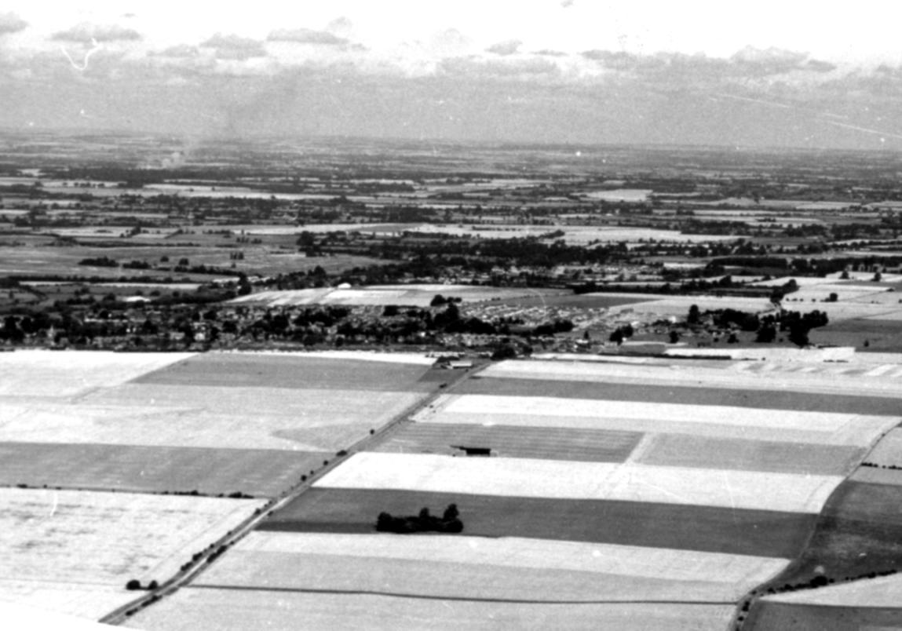
Another method was frequently used in the Wantage area to help reduce or spread the cost of hedging. The acts for Ardington and Wantage and Grove specified that the arable did not need to be with hedging. In the hamlet of West Challow, the act specified that no fencing was mandatory for the land on the south side of the closes called The Laines. At Letcombe Regis and East Challow the downs were included with the arable in requiring no fencing. In other words, the arable, and sometimes the downs, were divided and allotted in individual ownership, but were not necessarily separated from other holdings by a hedge, fence, mound, or ditch. Under a provision of the 1801 General Inclosure Act it was possible to continue working the arable as an open, and even common field system. The biggest difference would be that the land was in larger, consolidated units. While there is no evidence of common husbandry continuing in the Wantage area after enclosure, much of the arable was left unhedged. Looking at the area today, it is often assumed that the large fields have resulted from the modern tendency to grub up hedges. However, the tithe commissioner commented in the 1841 tithe report for Ardington, ‘The whole of the arable land though enclosed (or rather allotted) by and act of Parliament is open – not a vestige of a fence or even a boundary marker is to be seen. On his tour of England in 1851, the agriculturalist, James Caird, noted that in the countryside eastward from Wantage even public roads were unfenced and there were often no hedges dividing different kinds of crops in the fields. The large fields in the parishes on the 1883 Six-Inch Ordnance Survey Map confirm that little had changed. Even today the unhedged fields continue to give the landscape an open characteristic that few associate with enclosure. The impact of this on the landscape is particularly noticeable in much of northern Berkshire including Letcombe Regis and Wantage. In the four parishes, much of the area in the old open fields was probably never divided by hedges (see Fig. 5.10).
Fig 5.10 The field pattern in the Ardington area showing the largely unhedged fields that in the Wantage area are often the result enclosure rather than grubbing up of enclosure hedges in recent times. The 1801 Act allowed arable and down land to be made several but remain unfenced.
Source: MERL University of Reading

Today there is a great deal of interest in the preservation and replanting of hedgerows to ensure greater environmental bio-diversity. Woodlands attract similar interest. However, while enclosure promoted hedge planting, it had a more mixed impact on woodlands. On many of the larger estates owners planted trees as to enhance the appearance of their land, to create windbreaks and to provide cover for game and coverts for foxes. Scattered areas of woodland were planted in the years after enclosure on the Lockinge Estate making the area more densely wooded after enclosure than before. However, a provision in many enclosure acts gave the original owners of trees and bushes on land to be exchanged at enclosure the right to have trees on their land valued and demand payment from the new owner. If this were not paid, the original owner could cut the trees and remove them within a year of the award. Documentation of this is unusual but does exist for the Lambourn Almshouses Estate. Land that was to be exchanged, particularly that originally owned by the charity, was quite heavily wooded. Both William Wiseman Clarke and John Pollexfen Bastard agreed to take some of the standing trees. In spite of this, over £150 of timber was cut and sold off the estate. Many oaks scattered around the meadowland were also cut. The right to cut any trees that the new owner of exchanged land almost certainly led to the destruction of many acres of woodland at and just after enclosure.

Provision for the Poor

Many lost out at enclosure. The common and waste along with the right of shack on the arable disappeared and the village poor lost whatever use they had made of this land. The precise nature of the rights held by those in the village over the common land is unclear. In some parts of England an ‘ancient homestead’, also known as a common cottage, is generally thought to have had the right to graze two cows on the common. At the end of the eighteenth century this was calculated to have been worth between £14 and £20 per year, or 56 to 80 per cent of the average agricultural labourer’s annual income. The right to use the common to fatten a pig was valued at £3 to £4 10s, or 12 to 18 per cent of their annual income. However, since by no means all cottages were ‘ancient homesteads’, it is difficult to determine whom had rights to the common associated with a cottage. Sarah Cook claimed for common of pasture for two cows and the Hayward's Gore one year in every twenty as owner of a house in East Challow. She was awarded 0.10 of an acre of meadow in White Mead. Richard Castle a copyhold tenant of Corpus Christi College claimed common for three cows in Fox Mead, Ardington where he was awarded 0.02 of an acre. William Heading of Grove claimed commons for three cows and 60 sheep in Kingsgrove but does not appear to have been awarded any land. In a study of ten settlements in the south and east Midlands, it was found that only two to three per cent of agricultural labourers owned common cottages and another 13 to 18 per cent rented them. Arthur Young, a proponent of enclosure, believed that, in general, agricultural labourers and poor husbandmen did not have cottages that gave them rights to graze a cow, but often were able to graze cows without any legal rights. At Letcombe at least it would seem that many did graze cattle on the common. Young noted that in Letcombe, ‘The poor seem the greatest sufferers; they can no longer keep a cow, which before many of them did, and they are therefore now maintained by the parish.’ The abstract of claims for Letcombe Regis does not list any such claims. However, while only a limited number of the poor in a village had the legal right to graze animals on the common, in an area where there was no excessive pressure on the waste it is probable that many fed their livestock not by right but by indulgence or through the neglect the village officers.

The poor also often had common shackage or the right on the open fields to feed pigs and geese. Many more had other rights of common. The right to gather fuel on common land has been calculated at £2 to £5 or 8 to 20 per cent of the agricultural labour’s annual income. Even if the poor did not have access to common land for grazing and fatting livestock, its use was an important element in the well being of the agricultural labourer’s family. Gleaning on the common land also supplemented the family income of the poor. Once the major landowners had decided to enclose there was little the poor of the parish could do either to stop the process or to protect their own interests. Mavor, writing in the early nineteenth century noted, ‘On enclosure it is frequently found that too little regard had been paid to the real or customary rights of the poor.’ While the 1801 General Act for Inclosure did make some attempt to protect the small holder from the worst affects, little was done for the poor until the General Inclosure Act of 1845. This required that if there were waste of the manor with tenants having right of common, if the waste were unstinted, or if it were open all year for cattle levant and couchant, the parish could be required to set aside land to be used for allotments for the labouring poor. If the manor had a population of over 2000, it was also required to provide land for exercise and recreation. While the population of East Lockinge fell below the minimum figure for a recreation ground, the parish was required to establish allotments for the poor (see fig. 5.11) This allotment provided in lieu of the right to cut furze and bushes was
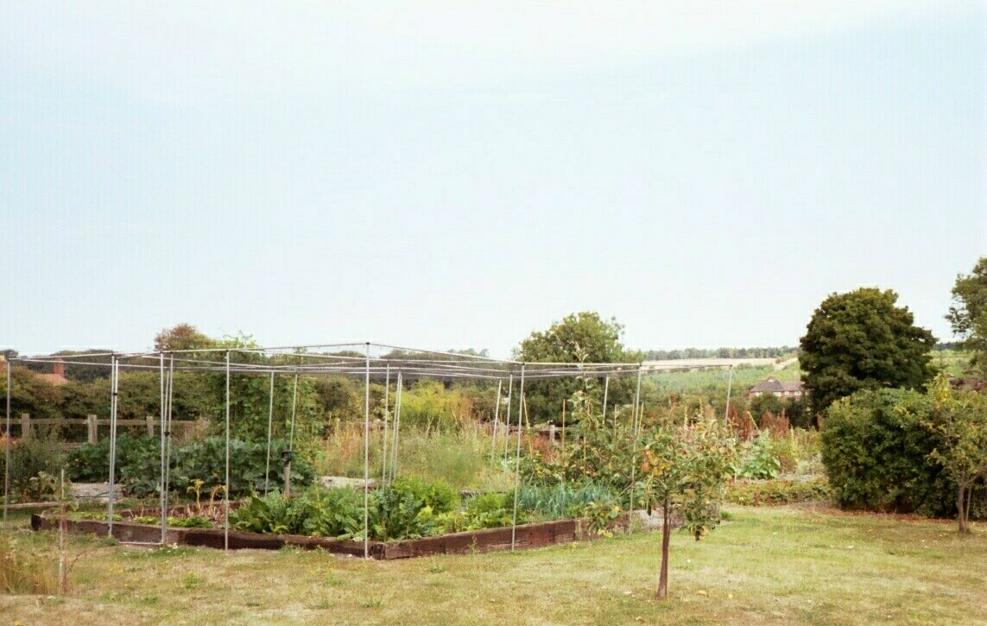
let out to labourers of the parish. It was 3 acre 1 rood 24perches and was divided into 43 equal plots. Although the size and the division of the allotment appears to have altered, this landscape feature remains today as a symbol of a more humanitarian attitude to the poor at the time of enclosure than had been taken at the time of other enclosures in the four parishes.
Fig. 5.11 Setting land aside to create allotments for the poor was one solution adopted by some parishes at enclosure as compensation for the loss of the common and waste. The enclosure allotments at East Lockinge, required under the conditions of the 1845 General Inclosure Act, were established in lieu of right to cut furze and bushes on the waste and common.

The polarisation of wealth encouraged by the need for efficiency and success that sprang out of enclosure had other visible manifestations in the landscape. The landscape reflected a change in attitude towards the poor. In the pre-enclosure community the needs of all were more easily met from the hedges and the commons and wastes. At enclosure the use of the common, whether by right or through indulgence and neglect, was lost to the poor. However, had the traditional practice of hedge making persisted, some of the needs of the poor could have been provided from the hedgerow. The hedges around old enclosures were between six and ten feet wide and provided a variety of wood, berries, and nuts. The variety of plants found in the old hedges was not, as is suggested by the technique of dating hedges by the number of species, simply because of years of haphazard volunteer growth of new plants. Often hedges were planted to provide for the needs of the community, including the poor. In the sixteenth century Thomas Tusser wrote that the abundance of fruit and fuel found in the hedges was one of the advantages of enclosures. By the time of the parliamentary enclosures in the early years of the nineteenth century attitudes had changed sufficiently that no such provision was made (see figs 5.12 and 5.13). The hedge was no longer seen as a means to augment the dietary and fuel - hawthorn was a poorly burning wood - needs of the poor. The hedge had become little more than a livestock barrier. The thinner it could be built, the less land it wasted. William Bushnell of Aston Tirrold, one of the enclosure commissioners for Wantage and Grove, believed that hedges took up space, harboured birds and insects, and shaded the corn. The verges again reflected the diminishing tolerance shown towards the poor, destitute, and itinerant. In the enclosures up until the fourth quarter of the eighteenth century roads and their verges were often sixty feet wide. This was reduced quite dramatically in the years that followed. While improved road making techniques were being introduced, this was initially applied to turnpikes. The reduction in width was at least in part to prevent the ‘illegitimate’ use of the verge for grazing livestock and for squatting by gypsies, vagabonds, and the poor of the parish.
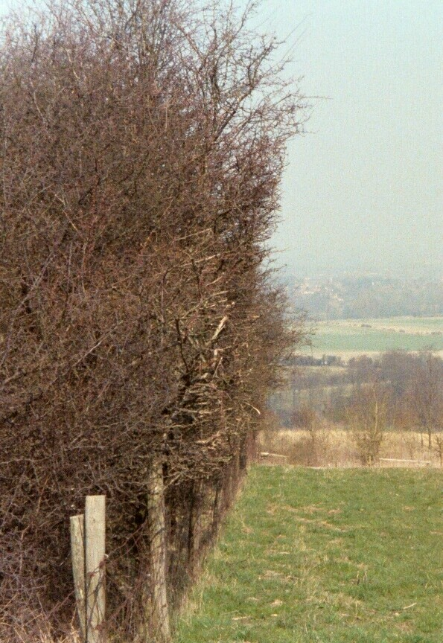
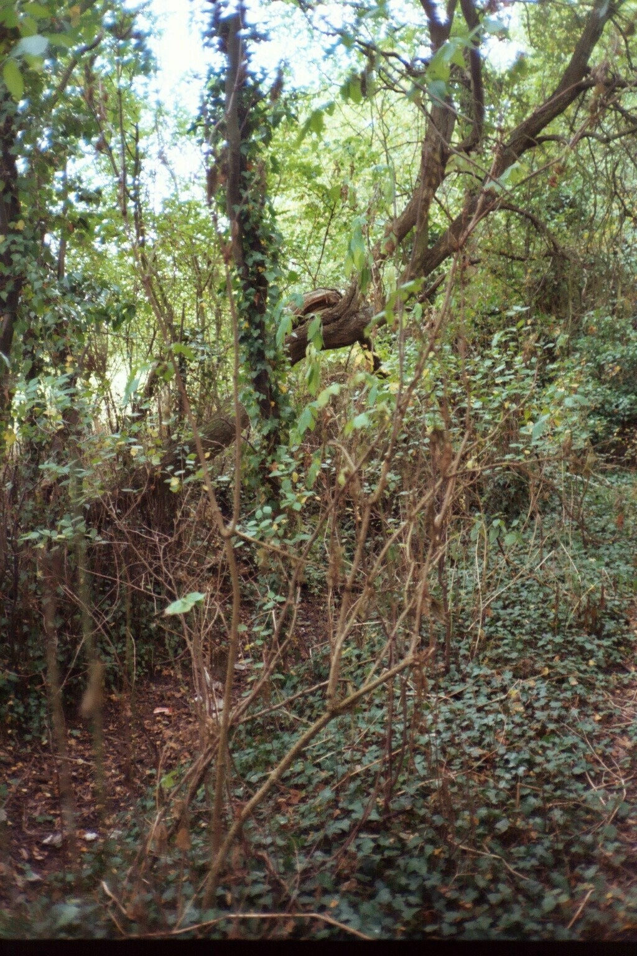
The ethos of the enclosure movement had been firmly stamped onto the surface of the English countryside. The movement began slowly and with much opposition. However, by the mid eighteenth century the momentum was sufficient that it could not be halted. In a century and a half, the enclosure commissioners appointed by act of parliament transformed the landscape of a fifth of the English countryside. They created an easily discernable,
quintessentially English landscape. Each region responded to the opportunities presented by enclosure in a way that reflected the type and timing of the enclosure along with the needs and aspirations of that community. In the Wantage area of Berkshire where over half the surface remained to be moulded by the commissioners, the impact was more muted than in some other enclosed areas. Because several of the enclosure acts made the fencing of the allotments optional on the arable and the downs, there are and have always been fewer miles of hedging than are found in most other area enclosed largely through act of Parliament. However, although the fields are unhedged they are still very much enclosed. Even without the hedges, the landscape was divided and allotted to create a rational and efficient network of farms. The successful were able to display their achievement in their isolated farmhouses surrounded by acres of neatly hedged, regularly shaped fields intersected by functional, straight roads. The landscape of parliamentary enclosure remains visible to any who cares to look at the evidence.
Figs. 5.12 and 5.13 demonstrate the different nature of an old enclosure hedge and one from the nineteenth century. The ancient hedge (left) from north of Grove is about ten feet wide and contains edible plants and a good supply of fuel. The later hedge (right) in Letcombe Regis is species poor and provides little apart from shelter and a stock-proof barrier. The two hedges illustrate the changing attitude of landowners towards the poor and the impact of this on the landscape.

Monk, 1794, 46
BRO D/ED E13A
.Dean, 50
Rackman, 190
Williamson, 72-3; Muir, 45
Muir, 45
Young, 1800, 93 & 95
41 Geo. III c.118 (1801); 42 Geo. III c.99 (1802); 43 Geo. III c. 106 (1803); 48 Geo. III c.74 (1808)
PRO IR 18/ 13096
Caird, 114
BRO D/QI C14
Shaw-Taylor, 2001a, 98
Shaw-Taylor, 2001b, 61, 2001, 645
BRO D/EEL E9
BRO D/QI E10
BRO Q/W 33
Shaw-Taylor, 2001a, 96
Young 1808, 12; 167-8
Young 1808, 150
Shaw-Taylor, 2001b, 61, 2001, 645; Neeson (1993), 165, Humphries (1990), 53
Mavor, 1809, 151
8&9 Vic, c.118 (1845)
BRO Q/RDc 87A
Turner, (1988), 115-16
Williamson, 12; Johnson, 1978, 195-204; Tusser, 102
Tusser, 102; Williamson, 12
Williamson 73-4; Young, 1813, 49
Mavor, 144
Taylor, 1979, 160
Turner, 1984, 147

